Contents

TASK 01 4

Comparison 4

Comparing those websites with “Signature Cuisine” website. 8

Wireframe 8

Sitemap 20

Task 02 21

Header 21

CSS 22

Front-end Section (User Section) 37

Back-end Section 47

Database 87

TASK 03 91

Testing 91

References 105

List of figures

Figure 1 Java Lounge UI 5

Figure 2 Crepe Runner 6

Figure 3 Coco veranda 7

Figure 4 Peppermint Cafe 8

|  |  |  |  |
| --- | --- | --- | --- |
| **Qualification** | | **Module Number and Title** | |
| Higher Diploma in Computing and Software Engineering | | Web Application Development - Website for **“Signature cuisine”** restaurant | |
| **Student Name & No.** | | **Assessor** | |
| Arjuna Anuhass CL/HDCSE/CMU/104/65 | |  | |
| **Hand out date** | | | **Submission Date** |
| 00/00/00 | | | 00/00/00 |
| **Assessment type**  WRIT1 -Coursework | **Duration/Length of**  **Assessment Type**  3000 words equivalent | | **Weighting of Assessment**  100% |

|  |  |
| --- | --- |
| **Learner declaration** | |
| I certify that the work submitted for this assignment is my own and research sources are fully acknowledged. | |
| |  |  |  |  | | --- | --- | --- | --- | | **Marks Awarded** | | | | | First assessor | |  | | | IV marks | |  | | | Agreed grade | |  | | | Signature of the assessor |  | Date |  | |

**Feedback Form**

**International College of Business & Technology**

**Module:** Web Application Development - Website for **“Signature cuisine”** restaurant

**Student:**

**Assessor:**

**Assignment:**

**Strong features of your work:**

**Areas for improvement:**

**Marks Awarded:**

**Course work**

**Learning outcomes covered**

# TASK 01

## Comparison

The “Signature Cuisine” website follows a conventional design with user friendly navigation and a seamless user experience. It offers relevant information that caters to the users’ most likely queries. The services and amenities are thoughtfully included based on user requirements. To make a comparison, we have several other Restaurant and Café websites at our disposal.

* **Java Lounge**

The website of Java Lounge displays a sleek and modern design that ensures easy navigation and a well-structured layout. It effectively conveys the café's ambiance and equipment information to its users. Customers can conveniently explore the menu through an appealing UI design, and the website also facilitates online ordering and doorstep food delivery. The site offers a wide array of coffee options, complete with details about each coffee's characteristics and pricing. This café is highly recommended by many users in Sri Lanka, who also speak highly of its excellent website. As a Java Lounge customer myself, I personally admire this user-friendly and highly improved website. (java, n.d.)

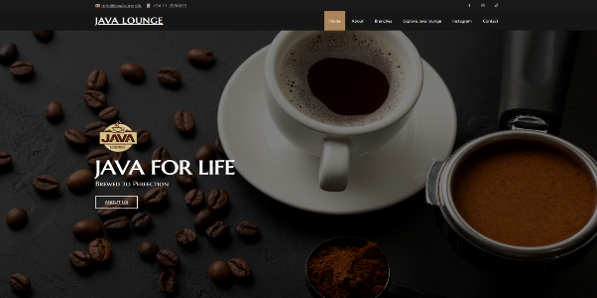

Figure 1 Java Lounge UI

* **Crepe Runner**

Crepe Runner impresses with its delightful and charming website design. The User Interface is creatively styled with cartoon elements, doodle wallpapers, and captivating images, drawing the attention of customers. The website's color scheme, featuring eye-catching chocolate tones, complements its focus on crepes as a delectable dessert and snack. The content is cleverly crafted around the chocolate theme. The services offered include delivery, customization, and online ordering. With its exceptional user-friendliness, the website entices visitors to scroll down and explore further. Personally, I find this website to be refreshingly unique in the realm of food websites, adding to its allure. (runner, 2023)

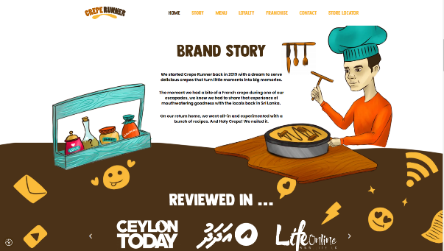

Figure 2 Crepe Runner

* **Coco Veranda**

Coco Veranda stands as a coffee lover's favorite destination. When we analyze the UI design of this website and compare it to the previous ones, it emerges as the most straightforward and user-friendly website. It features a one-page interface with only three navigation sections, highlighting its simplicity compared to others. Additionally, the website offers various amenities, including an online ordering section and a menu with prices for customers to view. Personally, I have had the pleasure of experiencing this website with a few companions, and its appeal to customers is undeniable. (veranda, 2023)

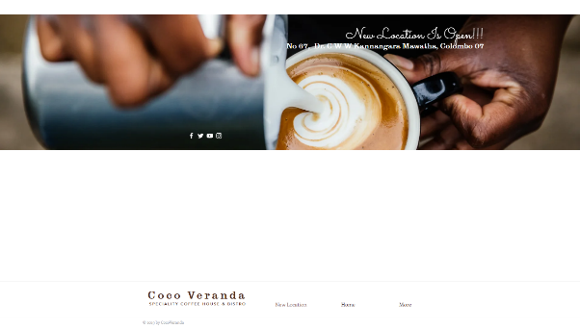

Figure 3 Coco veranda

* **Peppermint Café**

Peppermint Cafe takes the lead as the best UI design for a café or restaurant. The user interface is strikingly extravagant, and having a website has become essential in today's business landscape, contributing to the café's long-lasting success. The use of a simple and elegant black-and-white color theme adds to its attractiveness, while the logo designs, fonts, and images create a captivating visual impact. The user navigation system is exceptionally user-friendly, even for beginners, with popup menus and image hovering enhancing the website's overall sustainability. Compared to the previous three websites, Peppermint Cafe takes the top spot for its outstanding design and user experience. (cafe, 2023)

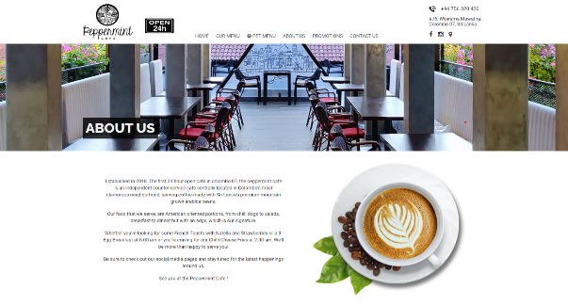

Figure 4 Peppermint Cafe

## Comparing those websites with “Signature Cuisine” website.

* Design and UI (User Interface):

Java Lounge offers users an appealing UI design, enabling them to place orders themselves. Crepe Runner impresses with its fantastic User Interface, created by skilled developers. Coco Veranda stands out for its simplicity and easy navigation, offering a pleasant personal experience. Lastly, Peppermint Cafe boasts the most beautiful and advanced UI designs, captivating customers more than other websites. Its navigation system is also user-friendly. Compared to "Signature Cuisine," all the cafes and restaurants discussed provide attractive designs and smooth navigation for a delightful user experience.

* Order food system

We have implemented a straightforward food ordering system, which has been the primary method utilized since the inception of our business. Initially, we offered a limited variety of food options, ensuring users can easily place their orders through the website.

## Wireframe

A wireframe of a UI website serves as the fundamental blueprint, outlining the skeletal structure and layout of the user interface before any visual design elements are implemented. It is a crucial step in the web development process, providing a clear and organized representation of the website's core elements and functionalities. Wireframes are typically devoid of color, graphics, or detailed typography, instead focusing on the arrangement of key components such as navigation menus, content sections, buttons, and forms. By presenting a simplified and abstract representation, wireframes allow designers, developers, and stakeholders to collaborate and visualize the website's information hierarchy and user flow. They help identify potential usability issues early on and facilitate quick iterations and improvements. A well-crafted wireframe acts as a guidepost, streamlining the subsequent design and development stages, ultimately leading to a user-friendly, visually appealing, and intuitive website.

**Home Section**

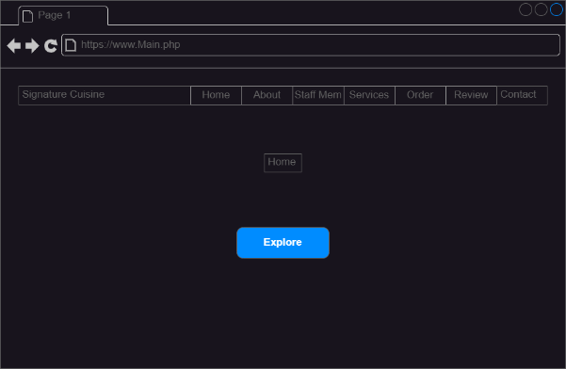

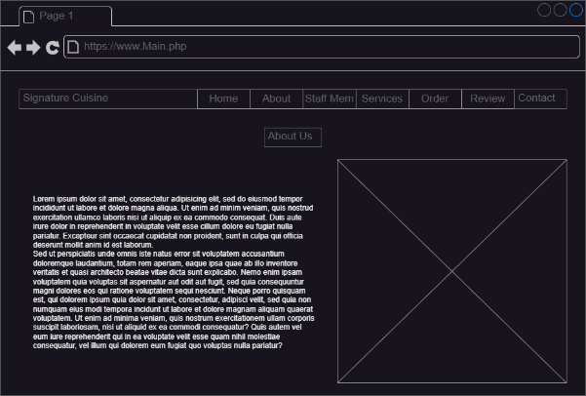

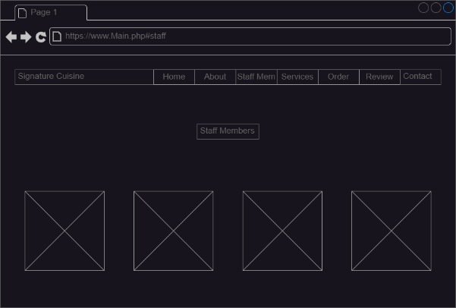

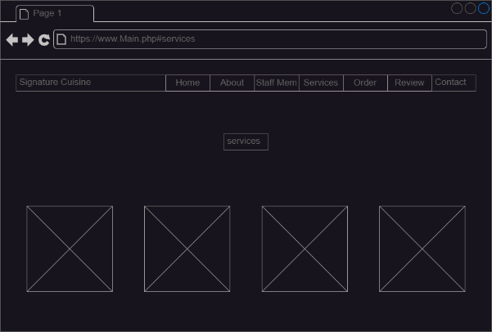

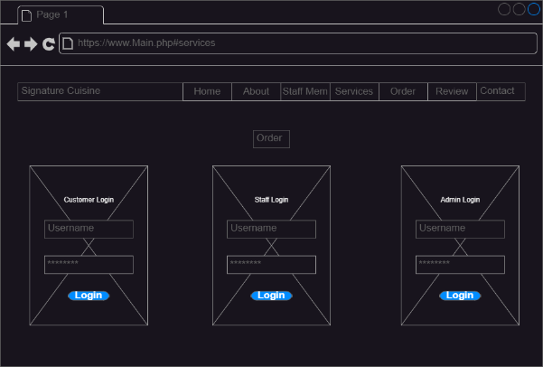

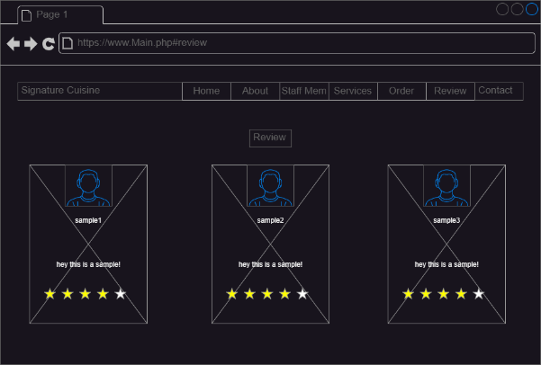

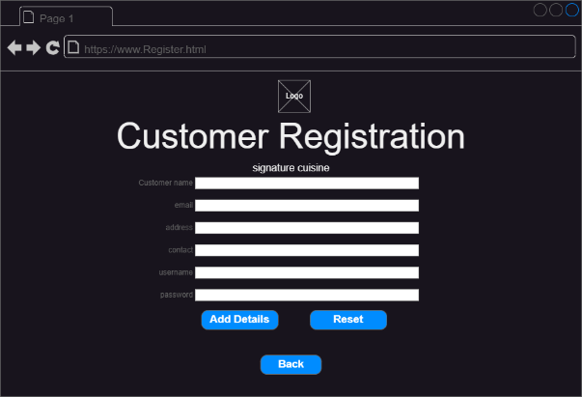

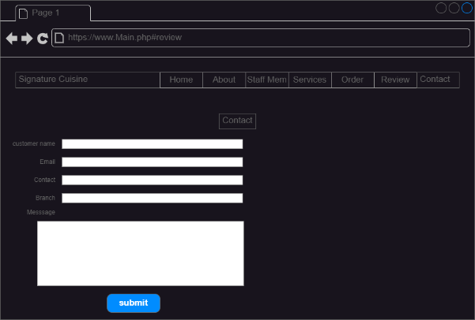

**Admin Section**

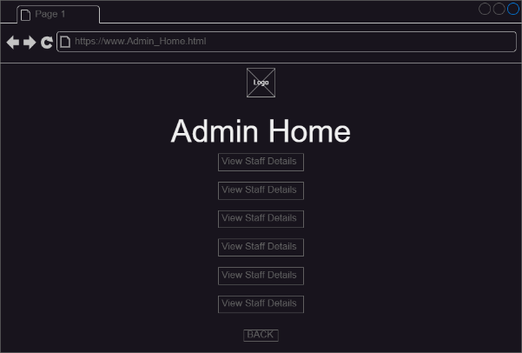

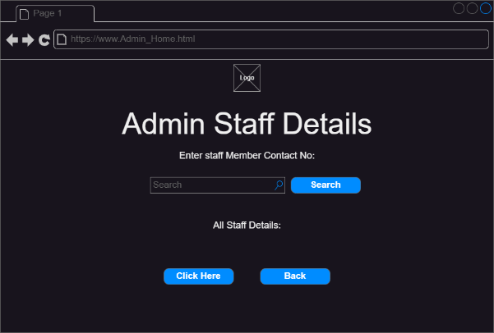

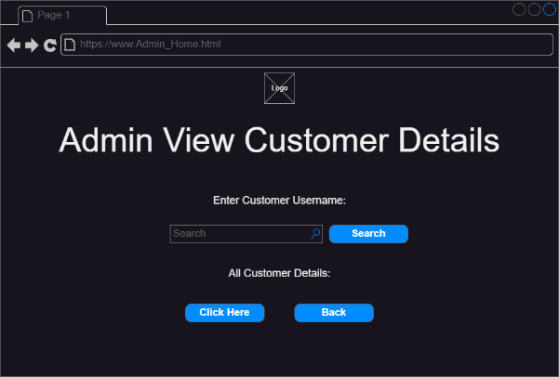

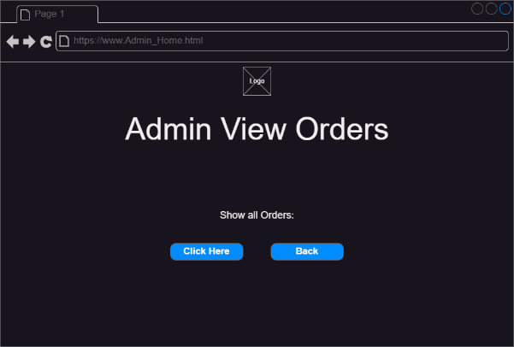

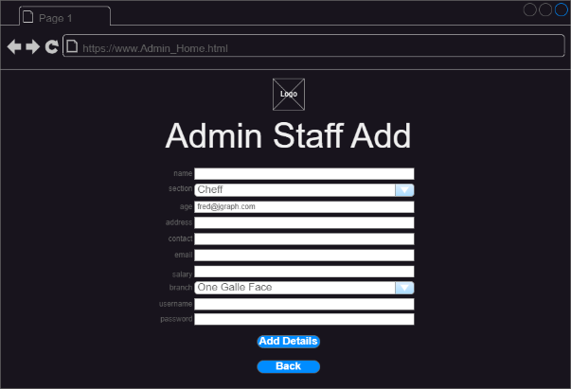

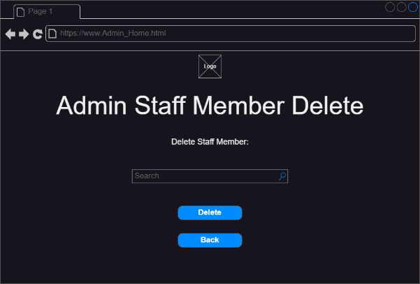

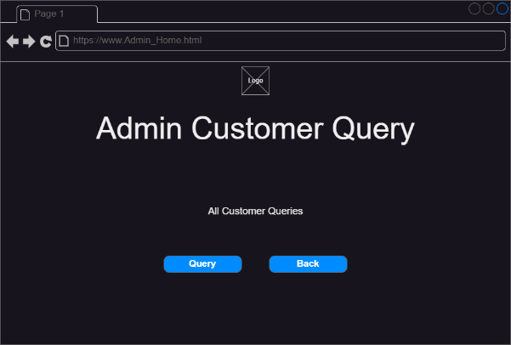

**User Section (Customer)**

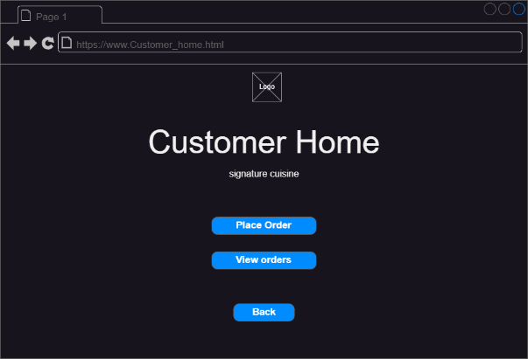

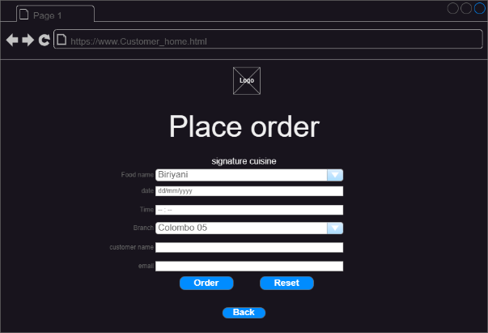

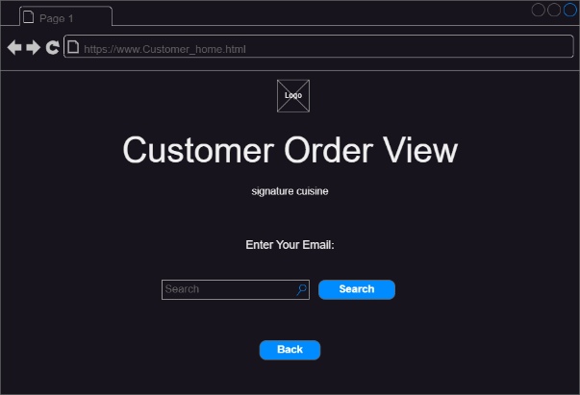

**Staff Section**

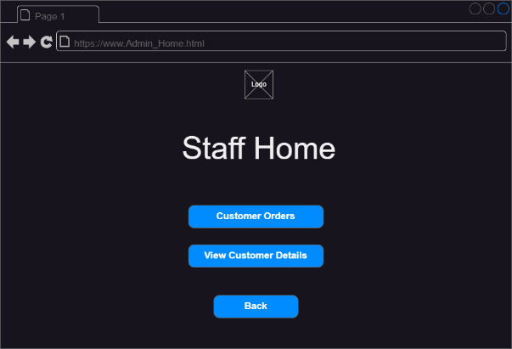

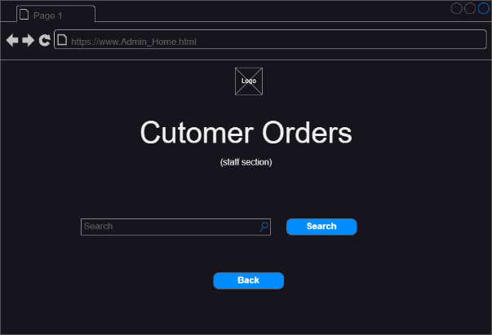

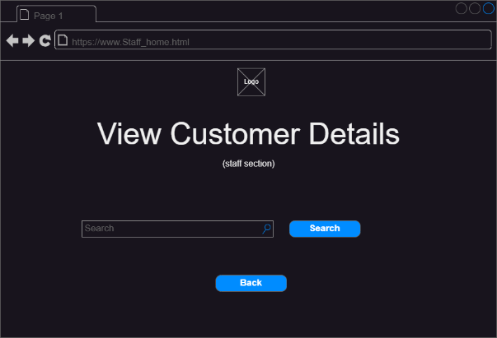

## Sitemap

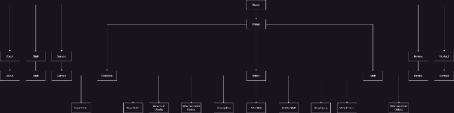

# Task 02

## Header

Main Page(Web Page)

<!DOCTYPE html>

<html lang="en">

<head>

    <meta charset="UTF-8">

    <meta name="viewport" content="width=device-width, initial-scale=1.0">

    <title>Signature Cuisine</title>

    <!-- font awesome cdn link  -->

    <link rel="stylesheet" href="https://cdnjs.cloudflare.com/ajax/libs/font-awesome/5.15.1/css/all.min.css">

    <!--Custom css file link-->

    <link rel="stylesheet" href="Web_Front-home.css">

</head>

## CSS

Web.php CSS Styles

:root{

    --c1:#303b52;

    --c2:#9ABAC9;

}

*{

    font-family: 'Roboto', sans-serif;

    text-transform: capitalize;

    text-decoration: none;

    outline: none;

    margin: 0;

    padding: 0;

    box-sizing: border-box;

}

*::selection{

    background: var(--c1);

    color: bisque;

}

html{

    font-size: 65%;

    overflow-x: hidden;

}

.heading{

    font-size: 7rem;

    color: #fff;

    text-align: center;

    padding: 0 1rem;

    padding-top: 6rem;

    letter-spacing: .2rem;

    font-weight: 500;

}

.title{

    padding: 0 1rem;

    font-size: 2rem;

    text-align: center;

    font-weight: 400;

    color: #cccccc;

    text-shadow: 1px 0 0 #000, 0 -1px 0 #000, 0 1px 0 #000, -1px 0 0 #000;

}

header{

    width: 96%;

    background: #fff;

    position: fixed;

    top: 2rem; left: 50%;

    transform: translateX(-50%);

    border-radius: 5rem;

    display: flex;

    align-items: center;

    justify-content: space-between;

    padding: 1rem 5rem;

    z-index: 1000;

    transition: .2s;

    opacity: 90%;

}

header .navbar ul{

    display: flex;

    align-items: center;

    justify-content: space-between;

    list-style: none;

}

header .navbar ul li{

    margin:0 2rem;

}

header .navbar ul li a{

    font-size: 2rem;

    color: #303b52;

    transition: .2s;

    border-bottom: 3px solid transparent;

}

header .navbar ul li .active,

header .navbar ul li a:hover{

    opacity: 30%;

    border-bottom: 3px solid #303b52;

    transition: 2s;

}

header .logo{

    font-size: 3rem;

    color: #303b52;

    font-family: 'Trebuchet MS', 'Lucida Sans Unicode', 'Lucida Grande', 'Lucida Sans', Arial, sans-serif;

}

/*header .logo img{

    height: 10vh;

    width: 10vw;

    padding: 20px;

}

header .logo p{

    color: var(--c1);

    padding:0 .2rem;

}*/

header .fa-bars{

    font-size: 3rem;

    color: var(--c1);

    cursor: pointer;

    display: none;

    transition: .2s;

}

.home{

    min-height: 100vh;

    background-image: url(images/coverp1.jpg);

    background-size: cover;

    background-position: center;

    background-attachment: fixed;

    z-index: 0;

    overflow: hidden;

    position: relative;

}

.home .content{

    display: flex;

    align-items: center;

    justify-content: center;

    flex-flow: column;

    padding-top: 14rem;

    padding-bottom: 8rem;

    text-align: center;

}

.home .content h1{

    font-size: 5rem;

    font-family: 'Copperplate' 'fantacy';

    color: #fff;

    padding:0 1rem;

    text-shadow: 0 .3rem .5rem rgba(0, 0, 0, .3);

    text-transform: uppercase;

    text-decoration: wavy;

}

.home .content p{

    font-size: 2rem;

    color:#eee;

    padding:5rem 25rem;

}

.home .content button{

    height:4rem;

    width:17rem;

    border-radius: 5rem;

    background: bisque;

    color:#000;

    font-size: 2rem;

    cursor: pointer;

    transition: 1s;

    border:none;

    box-shadow: 0 .3rem 1rem rgba(0,0,0,.3);

    font-weight: 500;

  }

  .home .content button:hover{

    letter-spacing: .2rem;

  }

  .home .box-container{

    display: flex;

    justify-content: center;

    flex-wrap: wrap;

  }

/*.home::before{

    content: '';

    position: absolute;

    bottom:-25rem; left:50%;

    transform: translateX(-50%);

    border-top: 70vh solid #fff;

    width:120%;

    border-radius: 50%;

    z-index: -1;

}*/

/*ABOUT STYLES STARTS*/

.about{

    min-height: 100vh;

    background: #1c2436;

    background-size: cover;

    background-position: center;

    background-attachment: fixed;

    z-index: 0;

    overflow: hidden;

    position: relative;

}

.about .row{

    display: flex;

    justify-content: center;

    align-items: center;

}

.about .row .image img{

    height: 70vh;

    width: 60vw;

}

.about .row .content{

    padding-left: 5rem;

}

.about .row .content h3{

    font-size: 4rem;

    color: #abbde4;

    padding-bottom: 15srem;

}

.about .row .content p{

    font-size: 1.5rem;

    color: #fff;

    padding: 5rem 0;

}

.about .row .content button{

    height: 4rem;

    width: 20rem;

    background: #303b52;

    color: #fff;

    border: none;

    border-radius: 5rem;

    box-shadow: 0 .3rem 1rem rgba(0,0,0,.3);

    cursor: pointer;

    font-size: 3rem;

    transition: 1s;

}

.about .row .content button:hover{

    letter-spacing: .2rem;

    opacity: 1;

}

/*ABOUT STYLES ENDS*/

/*STAFF MEMBER STYLES STARTS*/

.staff{

    min-height: 100vh;

    background-image: url(images/12.jpg);

    background-size: cover;

    background-position: center;

    background-attachment: fixed;

    z-index: 0;

    overflow: hidden;

    position: relative;

}

.staff .card-container{

    display: flex;

    align-items: center;

    justify-content: center;

    flex-wrap: wrap;

    padding: 2rem 0;

}

.staff .card-container .card{

    padding: 2rem;

    margin: 2rem;

    background: #fff;

    text-align: center;

    width: 28rem;

    box-shadow: 0 .3rem .5rem rgba(0,0,0,.3);

}

.staff .card-container .card img{

    height: 27rem;

    width: 100%;

    object-fit: cover;

    filter: grayscale(0);

    transition: 3s;

}

.staff .card-container .card:hover img{

    filter: grayscale();

}

.staff .card-container .card h3{

    color: #000;

    font-size: 3rem;

    padding: .5rem 0;

}

.staff .card-container .card p{

    font-size: 2rem;

    color: #cccccc;

}

.staff .card-container .card .icons a{

    font-size: 1.8rem;

    padding: 1.5rem .5rem;

    color: #303b52;

}

.staff .card-container .card .icons a:hover{

    opacity: 20%;

    transition: 1s;

}

/*STAFF MEMBER STYLES ENDS*/

/*SERVICES STYLES STARTS*/

.services{

    min-height: 100vh;

    background-image: url(images/10.jpg);

    background-size: cover;

    background-position: center;

    background-attachment: fixed;

    z-index: 0;

    overflow: hidden;

    position: relative;

}

.services .all-box{

    width: 85%;

    display: flex;

    justify-content: center;

    margin:0 auto;

    padding-top: 4rem;

    flex-wrap: wrap;

}

.services .all-box .box{

    height: 26rem;

    width: 30rem;

    margin: 3.5rem 2rem;

    text-align: center;

    border-radius: 1rem;

    box-shadow: .3rem .3rem 0 .1rem #000

                .5rem .5rem .5rem rgba(0, 0, 0, .3);

    background-color: #303b52;

}

.services .all-box .box h3{

    font-size: 3.5rem;

    color: #fff;

    padding-top: 5rem;

}

.services .all-box .box p{

    font-size: 1.5rem;

    color: bisque;

    padding-top: 3rem;

    padding-bottom: 3rem;

}

.services .all-box .box button{

    height: 2.0rem;

    width: 10rem;

    background: bisque;

    color: #000;

    border: none;

    border-radius: 5rem;

    box-shadow: 0 .3rem 1rem rgba(0, 0, 0, .3);

    cursor: pointer;

    transition: 1s;

}

.services .all-box .box button:hover{

    letter-spacing: .2rem;

    opacity: 75%;

}

/*SERVICES STYLES ENDS*/

/*ORDER STYLES STARTS*/

.order{

    min-height: 100vh;

    background-image: url(images/11.jpg);

    background-size: cover;

    background-position: center;

    background-attachment: fixed;

    z-index: 0;

    overflow: hidden;

    position: relative;

}

.order .all-face{

    display: flex;

    align-items: center;

    justify-content: center;

    flex-wrap: wrap;

    padding: 2rem 0;

}

.order .all-face .face{

    padding: 2rem;

    margin: 4rem;

    background: #fff;

    text-align: center;

    width: 32rem;

    height: 40rem;

    box-shadow: 0 .3rem .5rem rgba(0, 0, 0, .3);

    opacity: 85%;

}

.order .all-face .face h3{

    color: #000;

    font-size: 3.7rem;

    padding: 5rem 0;

}

.order .all-face .face h2{

    color: #006;

}

.order .all-face .face p{

    font-size: 1.7rem;

    color: #666;

}

.order .all-face .face a{

    font-size: 2rem;

    padding: 1.5rem .5rem;

    color: #000;

}

.order .all-face .face a:hover{

    color: blue;

}

.order .all-face .face .form-btn{

   height:3rem;

  width:12rem;

  background: bisque;

  color:#000;

  border:none;

  border-radius: 4rem;

  box-shadow: 0 .3rem 1rem rgba(0,0,0,.3);

  cursor: pointer;

  font-size:12px;

  transition: 1s;

}

.order .all-face .face .form-btn:hover{

    letter-spacing: .2rem;

    opacity: .8;

}

/*order styles ends*/

/*review styles starts*/

.review{

    min-height: 100vh;

    background-image: url(images/13.jpg);

    background-size: cover;

    background-position: center;

    background-attachment: fixed;

    z-index: 0;

    overflow: hidden;

    position: relative;

}

.review .box-container{

    display: flex;

    justify-content: center;

    padding-top: 4rem;

    flex-wrap: wrap;

}

.review .box-container .box{

    width: 28rem;

    height: 25rem;

    padding-bottom: 1rem;

    text-align: center;

    box-shadow: 0 .3rem .5rem rgba(0, 0, 0, .3);

    background: #fff;

    margin: 4rem 2rem;

}

.review .box-container .box img{

    height:8.5rem;

    width:8.5rem;

    object-fit: cover;

    border-radius: 50%;

    margin-top: -4rem;

    border:.45rem solid bisque;

    border-left:.45rem solid #999;

    border-bottom:.45rem solid #000;

    border-bottom: .45rem solid #999;

}

.review .box-container .box h3{

    font-size: 2rem;

    color: #303b52;

    padding: 0 .5rem;

}

.review .box-container .box p{

    font-size: 1.4rem;

    color:#999;

    padding:0 1.3rem;

    padding-top: 4rem;

}

.review .box-container .box .stars i{

    font-size: 1.6rem;

    color: rgb(130, 130, 151);

    padding:1.3rem .1rem;

    padding-top: 3rem;

}

/*review styles ends*/

/*contact styles starts*/

.contact{

    min-height: 100vh;

    background-image: url(images/14.jpg);

    background-size: cover;

    background-position: center;

    background-attachment: fixed;

    z-index: 0;

    overflow: hidden;

    position: relative;

}

.contact .form-container{

    width: 40%;

    padding-right: 5rem;

    margin-left: 5rem;

    margin-top: 3rem;

}

.contact .form-container input{

    font-size: 1rem;

}

.contact .form-container input, textarea{

    height: 2rem;

    width: 100%;

    background: transparent;

    border: 5;

    box-shadow: 0 0px 0px rgba(64, 64, 64, .7);

    color: #fff;

    border-radius: 5rem;

    padding: 1rem 2rem;

    margin: 1rem 0;

    font-size: 2rem;

    transition: 1s linear;

}

.contact .form-container input:focus, textarea:focus{

    border: .2rem solid #006;

}

.contact .form-container textarea{

    height: 14rem;

    border-radius: 1rem;

    padding: 1rem;

    resize: none;

    font-size: 2rem;

}

.contact .form-container input[type="submit"]{

    height: 4.2rem;

    width: 17rem;

    background: bisque;

    color: #000;

    cursor: pointer;

    font-size: 2rem;

    transition: 2s;

    margin-top: 5rem;

    margin-left: 15rem;

}

.contact .form-container input[type="submit"]:hover{

    background: #d1ffbd;

    color: #000;

    border: .2rem solid #000;

}

/*contact styles ends*/

.footer{

    text-align: center;

}

.footer .icons{

    padding: 3rem 0;

}

.footer .icons a{

    height: 4.5rem;

    width: 4.5rem;

    line-height: 4.2rem;

    text-align: center;

    border-radius: 50%;

    color: #1c2436;

    border: .2rem solid #000;

    font-size: 2rem;

    margin: .5rem;

    transition: 1s linear;

}

.footer .icons a:hover{

    color: #fff;

    background: bisque;

    border-color: #006;

}

.footer .credit{

    font-size: 2rem;

    border-top: .1rem solid #999;

    margin:0 auto;

    margin-bottom: 2rem;

    color:#666;

    width:90%;

    padding:1rem 0;

  }

  .footer .credit span{

    color: #000;

  }

  header .fa-times{

    transform: rotate(180deg);

    color: #1c2436;

  }

  /* media queries  */

@media (max-width:768px){

    html{

      font-size: 55%;

    }

    header .fa-bars{

      display: block;

    }

    header .navbar{

      position: fixed;

      top:-100rem; left:0;

      width:100%;

      background:#fff;

      border-radius: 1rem;

      opacity: 0;

      transition: .2s linear;

    }

    header .navbar ul{

      flex-flow: column;

      padding:2rem 0;

    }

    header .navbar ul li{

      margin:1rem 0;

      width:100%;

      text-align: center;

    }

    header .navbar ul li a{

      font-size: 3rem;

      display: block;

    }

    header .nav-toggle{

      top:5.5rem;

      opacity: 1;

    }

}

## Front-end Section (User Section)

<!DOCTYPE html>

<html lang="en">

<head>

    <meta charset="UTF-8">

    <meta name="viewport" content="width=device-width, initial-scale=1.0">

    <title>Signature Cuisine</title>

    <!-- font awesome cdn link  -->

    <link rel="stylesheet" href="https://cdnjs.cloudflare.com/ajax/libs/font-awesome/5.15.1/css/all.min.css">

    <!--Custom css file link-->

    <link rel="stylesheet" href="Web_Front-home.css">

</head>

<body>

<!-- Header Section Starts-->

<header>

    <a href="#" class="logo">Signature Cuisine</a>

    <nav class="navbar">

        <ul>

            <li><a href="#home" class="active">Home</a></li>

            <li><a href="#about">About Us</a></li>

            <li><a href="#staff">Staff Members</a></li>

            <li><a href="#services">Services</a></li>

            <li><a href="#order">Order</a></li>

            <li><a href="#review">Review</a></li>

            <li><a href="#contact">Contact</a></li>

        </ul>

    </nav>

    <div class="fas fa-bars"></div>

</header>

<!--Header section Ends-->

<!--Home section Starts-->

<section class="home" id="home">

<div class="content">

    <h1>Signature Cuisine</h1>

    <p>The pub now has two restaurants serving anything from sausages to shark steaks</p>

    <a href="#"><button>Explore</button></a>

</section>

<!--About section starts-->

<section class="about" id="about">

<h1 class="heading">About Us</h1>

<h3 class="title">Buy Some Food and Enjoy With Your Family</h3>

<div class="row">

    <div class="content">

        <h3>WE Take Care About Your Hospitality Convenience</h3>

        <p>Since our modest beginnings in 2005 with a little space in Torontos stylish Yorkville locale,

            Organization Names development has been enlivened with the energy to cook and serve solid, Indian-roused takeout food.</p>

        <a href="#"><button>Learn More</button></a>

    </div>

    <div class="image">

        <img src='images/04.jpg' alt="">

    </div>

</section>

<!--about section ends-->

<!--staff member section starts-->

<section id="staff" class="staff">

<h1 class="heading">Our Staff Members</h1>

<h3 class="title">Meet our valuable staff</h3>

<div class="card-container">

    <div class="card">

        <img src="images/05.jpg" alt="">

        <h3>Mr.Anuhass</h3>

        <p>CEO of the Restuarant</p>

        <div class="icons">

            <a href="#" class="fab fa-facebook-f"></a>

            <a href="#" class="fab fa-instagram"></a>

            <a href="#" class="fab fa-twitter"></a>

            <a href="#" class="fab fa-github"></a>

        </div>

    </div>

    <div class="card">

        <img src="images/06.png" alt="">

        <h3>Ms.Onarli</h3>

        <p>Marketing Manager</p>

        <div class="icons">

            <a href="#" class="fab fa-facebook-f"></a>

            <a href="#" class="fab fa-instagram"></a>

            <a href="#" class="fab fa-twitter"></a>

            <a href="#" class="fab fa-github"></a>

        </div>

    </div>

    <div class="card">

        <img src="images/07.jpg" alt="">

        <h3>Mr.Samitha</h3>

        <p>Main Chef</p>

        <div class="icons">

            <a href="#" class="fab fa-facebook-f"></a>

            <a href="#" class="fab fa-instagram"></a>

            <a href="#" class="fab fa-twitter"></a>

            <a href="#" class="fab fa-github"></a>

        </div>

    </div>

    <div class="card">

        <img src="images/08.jpg" alt="">

        <h3>Mr.Aadesh</h3>

        <p>Bakery Chef</p>

        <div class="icons">

            <a href="#" class="fab fa-facebook-f"></a>

            <a href="#" class="fab fa-instagram"></a>

            <a href="#" class="fab fa-twitter"></a>

            <a href="#" class="fab fa-github"></a>

        </div>

    </div>

    <div class="card">

        <img src="images/09.jpg" alt="">

        <h3>Mr.Minidu</h3>

        <p>Branch Manager</p>

        <div class="icons">

            <a href="#" class="fab fa-facebook-f"></a>

            <a href="#" class="fab fa-instagram"></a>

            <a href="#" class="fab fa-twitter"></a>

            <a href="#" class="fab fa-github"></a>

        </div>

    </div>

</div>

</section>

<!--Staff member section ends-->

<!--Services section starts-->

<section class="services" id="services">

    <h1 class="heading">Services</h1>

    <h3 class="title">Best of Restuarant field</h3>

<div class="all-box">

    <div class="box">

        <h3>Dine- In</h3>

        <p>customers will be able to order dine-in desserts by touching the screen</p>

        <a href="#"><button>View</button></a>

    </div>

    <div class="box">

        <h3>Home Delivery</h3>

        <p>Straight out of the oven to your doorstep</p>

        <a href="#"><button>View</button></a>

    </div>

    <div class="box">

        <h3>Outdoor Catering</h3>

        <p>The restaurant has a catering and delivery service</p>

        <a href="#"><button>View</button></a>

    </div>

    <div class="box">

        <h3>Drive-thru</h3>

        <p>In route, he pulled into a fast food drive-through and ordered two hamburger meals.</p>

        <a href="#"><button>View</button></a>

    </div>

    <div class="box">

        <h3>Bar & Lounge</h3>

        <p>cAt six o'clock we pulled off the highway and found a family style restaurant in a small Maryland town.</p>

        <a href="#"><button>View</button></a>

    </div>

</div>

</section>

<!--services section ends-->

<!--order section starts-->

<section class="order" id="order">

    <h1 class="heading">Orders</h1>

    <h3 class="title">Place and order and taste your Food!</h3>

    <div class="all-face">

        <div class="face">

    <div class="form-container">

        <form name="customerform" method="post" action="login.php">

            <h3>Customer Login</h3>

            <br>

            <h2>Username : <input type="text" name="username" required placeholder="enter your email"></h2>

            <br>

            <h2>Password : <input type="password" name="password" required placeholder="enter your password"></h2>

            <br>

            <input type="submit" name="submit" value="login now" class="form-btn">

            <br>

            <br>

            <br>

            <p>Don't have an account? <a href="Register.php">register now</a></p>

<?php

/*$conn = mysqli_connect('localhost','root','','sig_cuisine');

if(!$conn) {

    die("Clould not connect : " .mysqli_error($conn));

}

if($conn) {

    echo"<font color='#009900'> Database connected Successfully";

    echo"<br/>";

}*/

include "Connection.php";

?>

        </form>

    </div>

    </div>

    <div class="face">

        <div class="form-container">

            <form name="staffform" method="post" action="Login.php">

                <h3>Staff Login</h3>

                <h2>Username : <input type="text" name="username" required placeholder="Enter Your Username"> </h2><br>

                <h2>Password : <input type="password" name="password" required placeholder="Enter Your Password"> </h2><br>

                <input type="submit" name="btn_staff" value="login now" class="form-btn">

            </form>

<?php

   /* $conn = mysqli_connect('localhost','root','','sig_cuisine');

    if(!$conn){

    die("Could not connect : ".mysqli_error($conn));

    }

    if($conn){

    echo"<font color='#009900'>Database connected successfully";

    echo"<br/>";

    }*/

include "Connection.php";

?>

        </div>

    </div>

    <div class="face">

            <div class="form-container">

                <form name="adminform" method="post" action="login.php">

                <h3>Admin Login</h3>

                <h2>Username : <input type="text" name="username" required placeholder="Enter Your Username"></h2><br>

                <h2>Password : <input type="password" name="password" required placeholder="Enter Your Password"></h2><br>

                <input type="submit" name="btn_admin" value="Login now" class="form-btn">

                </form>

            </div>

        </div>

    </div>

</section>

<!--order section ends-->

<!--review section starts-->

<section class="review"  id="review">

    <h1 class="heading">Review</h1>

    <h3 class="title">Here are Customer Reviews</h3>

    <div class="box-container">

        <div class="box">

            <img src="images/17.jpg" alt="">

            <h3>Lushantha</h3>

            <p>nice food and amazing Staff</p>

            <div class="stars">

                <i class="fas fa-star"></i>

                <i class="fas fa-star"></i>

                <i class="fas fa-star"></i>

                <i class="fas fa-star"></i>

                <i class="fas fa-star"></i>

            </div>

        </div>

        <div class="box">

            <img src="images/18.jpg" alt="">

            <h3>Priyantha</h3>

            <p>Amazing delicious food</p>

            <div class="stars">

                <i class="fas fa-star"></i>

                <i class="fas fa-star"></i>

                <i class="fas fa-star"></i>

                <i class="fas fa-star"></i>

                <i class="fas fa-star"></i>

            </div>

        </div>

        <div class="box">

            <img src="images/19.jpg">

            <h3>Sandaru</h3>

            <p>awesome food i ever had</p>

            <div class="stars">

                <i class="fas fa-star"></i>

                <i class="fas fa-star"></i>

                <i class="fas fa-star"></i>

                <i class="fas fa-star"></i>

            </div>

        </div>

        <div class="box">

            <img src="images/20.jpg">

            <h3>Lokitha</h3>

            <p>Nicve food but want more variety of menu</p>

            <div class="stars">

                <i class="fas fa-star"></i>

                <i class="fas fa-star"></i>

                <i class="fas fa-star"></i>

                <i class="fas fa-star"></i>

                <i class="fas fa-star-half-alt"></i>

            </div>

        </div>

    </div>

</section>

<!--review sections ends-->

<!--contact section starts-->

<section class="contact" id="contact">

    <h1 class="heading">Contact</h1>

    <h3 class="title">Hey! We gladly wanna know about your thoughts</h3>

    <div class="form-container">

        <form method="post" action="Query_Web.php">

            <input type="text" name="C_name" placeholder="Customer Name">

            <input type="email" name="C_email" placeholder="Customer Email">

            <input type="number" name="C_contact" placeholder="Customer Contact">

            <input type="text" name="C_branch" placeholder="Customer Branch">

            <textarea name="C_message" id="" cols="30" rows="10" placeholder="Message to Us"></textarea>

            <input type="submit" name="submit" value="Tell Us">

        </form>

    </div>

</section>

<!--Contact section ends-->

<section class="footer">

    <div class="icons">

        <a href="https://www.facebook.com/" class="fab fa-facebook-f"></a>

        <a href="https://twitter.com/i/flow/login?redirect_after_login=%2F%3Flang%3Den" class="fab fa-twitter"></a>

        <a href="https://www.instagram.com/" class="fab fa-instagram"></a>

        <a href="https://github.com/" class="fab fa-github"></a>

        <a href="https://www.tiktok.com/en/" class="fab fa-tiktok"></a>

    </div>

    <div class="credit">Created by <span>Mr. Arjuna Anuhass</span></div>

</section>

    <!--JavaScript link-->

    <script src="https://cdnjs.cloudflare.com/ajax/libs/jquery/3.5.1/jquery.min.js"></script>

    <!--Custom Javascript link-->

    <script src="Web.js"></script>

</body>

</html>

## Back-end Section

1. All the Database connect to a one database that I created is named as “Connection.php”. This one is connecting each php database file that I used.

<?php

$dbhost = 'localhost';

$dbuser = 'root';

$dbpass = '';

$conn= mysqli_connect($dbhost,$dbuser,$dbpass);//ist opens a connection with db

if(!$conn)

{

    die('Could not connect: '.mysqli_error($conn));

}

echo'Database Connected successfully';

echo"<br/>";

$db = mysqli_select_db($conn,'sig_cuisine');//select the database

if(!$db)

{

    echo'select the database first';

}

else{

    echo'<br/>Database connected: ';

}

//mysqli close($conn)

?>

1. Database to Register Users “Register.php”.

<!DOCTYPE html>

<html lang="en">

<head>

    <meta charset="UTF-8">

    <meta name="viewport" content="width=device-width, initial-scale=1.0">

    <title>Register</title>

    <link rel="stylesheet" href="Reg.css">

</head>

<body>

<center>

    <div class="image">

        <img src="images/03.jpg">

    </div>

    <div class="title">

    <h2>Customer Registration</h2>

    </div>

    <div class="sentences">

        <p>Register and enjoy your Foods</p>

    </div>

    <br>

<?php

/*$dbhost = 'localhost';

$dbuser = 'root';

$dbpass = '';

$db = 'sig_cuisine';*/

/*$conn = mysqli_connect('127.0.0.1','root',"",'sig_cuisine');//important

if(!$conn){

    die('Could not connect :'.mysqli);

}

if($conn){

    echo"<font color='#009900'> Database connected successfully ";

    echo"<br/>";

}*/

include "Connection.php";

    $sql= "SELECT * FROM register";

    $result = mysqli_query($conn,$sql);

?>

<div class="card-container">

    <div class="tab1">

        <form name="form" method="post" action="">

            <table border="4">

                <thead>

                    <tr>

                        <th>Customer Name</th>

                        <td>

                        <input type="text" name="customername" id="customername">

                        </td>

                    </tr>

                    <tr>

                        <th>E-mail</th>

                        <td>

                            <input type="text" name="cusemail" id="cusemail">

                        </td>

                    </tr>

                    <tr>

                        <th>Contact</th>

                        <td>

                            <input type="text" name="cuscontact" id="cuscontact">

                        </td>

                    </tr>

                    <tr>

                        <th>Address</th>

                        <td>

                            <input type="text" name="cusaddress" id="cusaddress">

                        </td>

                    </tr>

                    <tr>

                        <th>Username</th>

                        <td>

                            <input type="text" name="username" id="username">

                        </td>

                    </tr>

                    <tr>

                        <th>Password</th>

                        <td>

                            <input type="password" name="password" id="password">

                        </td>

                    </tr>

                    <tr id="btna">

                        <td colspan="2">

                            <button type="submit" name="submit" value="">Add Details</button>

                        </td>

                    </tr>

                    <tr id="btna1">

                        <td colspan="2">

                            <button type="reset" name="reset" value="">Reset</button>

                        </td>

                    </tr>

                </thead>

            </table>

        </form>

<?php

if(isset($_POST['submit'])){

    $customername = mysqli_real_escape_string($conn,$_POST['customername']);

    $cusemail = mysqli_real_escape_string($conn,$_POST['cusemail']);

    $cuscontact = mysqli_real_escape_string($conn,$_POST['cuscontact']);

    $cusaddress = mysqli_real_escape_string($conn,$_POST['cusaddress']);

    $username = mysqli_real_escape_string($conn,$_POST['username']);

    $password = md5($_POST['password']);

    if($customername=="" && $cusemail=="" && $cuscontact=="" && $cusaddress=="" && $username=="" && $password=="")

    {

        echo'<script type="text/javascript">alert("ERROR    : Please fill in the blanks!!!")</script>';

        print"<font color='#FF0000'>Error    : Please fill in the blanks!!!";

    }

    else

    {

        $insert = "INSERT INTO register(customer_name, email, contact, address, username, password)

        VALUES('$customername', '$cusemail', '$cuscontact', '$cusaddress', '$username', '$password')";

        $result=mysqli_query($conn,$insert);

        if($result)

        {

            echo"<font color='#009900'> Data regisiter Succesfully";

            echo"<br/>";

            echo'<script type="text/javascript">alert("Data register successfully!")</script>';

        }

        else

        {

            echo '<script type="text/javascript"> alert("Data regisiter Unuccesfully") </script>';

            print"<font color='#FF0000'>Error    :   Data regisiter Unuccesfully !!!!!!!! ";

            echo"<br/>";

        }

    }

}

?>

    </div>

</div>

<a href="Web.php">

    <button type="button" name="submit" class="back">Back</button>

</a>

</center>

</body>

</html>

1. Database to Login details and Validating “Login.php”.

<?php

include"Connection.php";

$sql = "SELECT * FROM register";

$result = mysqli_query($conn,$sql);

?>

<?php

//Customer Login

if(isset($_POST['submit'])){

    if(empty($_POST['username']) || empty($_POST['password'])){

        echo"Please fill the Blanks!";

    }

    else{

        $username=mysqli_real_escape_string($conn,$_POST['username']);

        $password=mysqli_real_escape_string($conn,$_POST['password']);

        $sql="SELECT * FROM register Where username='$username' AND password='$password' LIMIT 1";

        $result=mysqli_query($conn,$sql);

        if(mysqli_num_rows($result)==1){

            echo"Customer User Login Successfull...";

            header("location:Customer_home.html");

        }

        else{

            print"<font color='#FF0000'> Please check your Username or Password!!!";

            echo'<script type="text/javascript"> alert("Login Unsuccessfull!!!") </script>';

        }

    }

}

//Staff Login

if(isset($_POST['btn_staff'])){

    if(empty($_POST['username']) || empty($_POST['password'])){

        echo"Please fill in the blanks!";

    }

    else{

        $username=mysqli_real_escape_string($conn, $_POST['username']);

        $password=mysqli_real_escape_string($conn, $_POST['password']);

        $sql="SELECT * FROM staff Where username='$username' AND password='$password' LIMIT 1";

        $result=mysqli_query($conn,$sql);

        if(mysqli_num_rows($result)==1){

            echo"Staff User Login Successfull...";

            header("location:Staff_home.html");

        }

        else{

            print"<font color='#FF0000'> Please check your Username or Password!!!";

            echo'<script type="text/javascript"> alert("Login Unsuccessfull!!!") </script>';

        }

    }

}

//Admin Login

if(isset($_POST['btn_admin'])){

    if(empty($_POST['username']) || empty($_POST['password'])){

        echo"Please fill in the blanks!!!";

    }

    else{

        $username=mysqli_real_escape_string($conn, $_POST['username']);

        $password=mysqli_real_escape_string($conn, $_POST['password']);

        if($username=="admin" && $password=="1234"){

            echo"User Login Successfull";

            header("location:Admin_home.html");

        }

        else{

            print"<font color='#ff0000'> Please check Your Username or Password!!!";

            echo'<script type="text/javascript"> alert("Login Unsuccessfull!") </script>';

        }

    }

}

?>

1. Database to view staff details “Admin_Staff_Details.php”.
2. <!DOCTYPE html>
3. <html lang="en">
4. <head>
5. <meta charset="UTF-8">
6. <meta name="viewport" content="width=device-width, initial-scale=1.0">
7. <title>Admin Staff Details</title>
8. <link href="adminfront.css" rel="stylesheet" type="text/css">
9. </head>
10. <body>
11. <center>
12. <div class="image">
13. <img src="images/03.jpg">
14. </div>
15. <div class="title">
16. <h1>Admin Staff Details</h1>
17. </div>
18. <div class="sentences">
19. <p>Welcome Admin...</p>
20. </div>
21. <br>
22. <br/>
23. <br>
24. <br/>
25. <br>
26. <br/>
27. <form method="post">
28. <h3>Enter Staff Member Contact No:</h3>
29. <input type="text" placeholder="Search" name="search">
30. <button type="submit" name="br_staff" id="br_staff" class="branch_s">Search</button>
31. <br>
32. <br/>
33. <br>
34. <br/>
35. <h3>All Staff Details :</h3>
36. <button type="submit" name="all_staff" id="all_staff" class="all_staff">Click Here</button>
37. <a href="Admin_home.html">
38. <button type="button" name="all_staff" class="previous">Previous</button>
39. </a>
40. </form>
41. <?php
42. include "Connection.php";
43. $sql = "SELECT * FROM staff";
44. $result = mysqli_query($conn,$sql);
45. ?>
46. <div class="container">
47. <table class="table">
49. <?php
50. if(isset($_POST['br_staff'])){
52. $search=$_POST['search'];
53. if($search==""){
54. print"<font color='#ff0000'>Error   :  Please fill in the blanks!!!";
55. echo"<br/>";
56. }
57. $sql = "SELECT * FROM staff Where contact='$search'";
58. $result = mysqli_query($conn,$sql);
59. if($result){
60. if(mysqli_num_rows($result)>0){
61. echo'<thead class="name">
62. <tr>
63. <th>Staff Member Name</th>
64. <th>Section</th>
65. <th>Age</th>
66. <th>Address</th>
67. <th>Contact</th>
68. <th>Email</th>
69. <th>Branch</th>
70. <th>Salary</th>
71. <th>Username</th>
72. <th>Password</th>
73. </tr>
74. </thead>
75. ';
76. while($row=mysqli_fetch_assoc($result)){
77. echo'<tbody>;
78. <tr>
79. <td> '.$row['staff_member_name'].' </td>
80. <td> '.$row['section'].' </td>
81. <td> '.$row['age'].' </td>
82. <td> '.$row['address'].' </td>
83. <td> '.$row['contact'].' </td>
84. <td> '.$row['email'].' </td>
85. <td> '.$row['branch'].' </td>
86. <td> '.$row['salary'].' </td>
87. <td> '.$row['username'].' </td>
88. <td> '.$row['password'].' </td>
89. </tr>
90. </tbody>
91. ';
92. }
93. }
94. else{
95. print"<font color='#ff0000'>Error    :  Data not Found!!!";
96. }
97. }
98. else{
99. print"<font color='#ff0000'>Error    :  Select the Correct Database!!!";
100. }
101. }
102. ?>
103. </table>
105. <table class="table1">
107. <?php
108. if(isset($_POST['all_staff'])){
109. $sql = "SELECT * FROM staff";
110. $result = mysqli_query($conn,$sql);
111. if($result){
112. if(mysqli_num_rows($result)>0){
113. echo'<thead class="name">
114. <tr>
115. <th>Staff Member Name</th>
116. <th>Section</th>
117. <th>Age</th>
118. <th>Address</th>
119. <th>Contact</th>
120. <th>Email</th>
121. <th>Branch</th>
122. <th>Salary</th>
123. <th>Username</th>
124. <th>Password</th>
125. </tr>
126. </thead>
127. ';
129. while($row=mysqli_fetch_assoc($result)){
130. echo'<tbody>;
131. <tr>
132. <td> '.$row['staff_member_name'].' </td>
133. <td> '.$row['section'].' </td>
134. <td> '.$row['age'].' </td>
135. <td> '.$row['address'].' </td>
136. <td> '.$row['contact'].' </td>
137. <td> '.$row['email'].' </td>
138. <td> '.$row['branch'].' </td>
139. <td> '.$row['salary'].' </td>
140. <td> '.$row['username'].' </td>
141. <td> '.$row['password'].' </td>
142. </tr>
143. </tbody>
144. ';
145. }
146. }
147. else{
148. print"<font color='#ff0000'>Error    :  Data not Found!!!";
149. }
150. }
151. else{
152. print"<font color='#ff0000'>Error    :  Select the correct Database!!!";
153. }
154. }
155. ?>
156. </table>
157. </div>
158. </center>
159. </body>
160. </html>

5. Database to View Customer Details “Admin_Customer_Details.php”.

<!DOCTYPE html>

<html lang="en">

<head>

    <meta charset="UTF-8">

    <meta name="viewport" content="width=device-width, initial-scale=1.0">

    <title>Admin Staff Add</title>

    <link href="adminfront.css" rel="stylesheet" type="text/css">

</head>

<body>

<center>

    <div class="image">

        <img src="images/03.jpg">

    </div>

    <div class="title">

        <h1>Admin View Customer Details</h1>

    </div>

    <div class="sentences">

        <p>Welcome Admin...</p>

    </div>

    <br>

    <br/>

    <form method="post">

        <h3>Enter Customer Username:</h3>

        <input type="text" placeholder="Search" name="search" class="search">

        <button type="submit" name="submit">Search</button>

        <br>

        <br/>

        <br>

        <br/>

        <br>

        <br/>

        <h3>All Customer Details:</h3>

        <button type="submit" name="btn_cus" id="btn_cus" class="btn_cus">Click Here</button>

        <a href="Admin_home.html">

            <button type="button" name="submit" class="previous">Previous</button>

        </a>

    </form>

    <?php

    include "Connection.php";

    ?>

    <div class="container">

        <table class="table">

            <?php

            if(isset($_POST['submit'])){

                $search=$_POST['search'];

                if($search==""){

                    print"<font color='#ff0000'>Error   :  Please fill in the blanks!!!";

                    echo"<br/>";

                }

                $sql = "SELECT * FROM register Where username='$search'";

                $result=mysqli_query($conn,$sql);

                if($result){

                    if(mysqli_num_rows($result)>0){

                        echo'<thead class="name">

                        <tr>

                        <th>Customer Name</th>

                        <th>Email</th>

                        <th>Contact</th>

                        <th>Address</th>

                        <th>Username</th>

                        <th>Password</th>

                        </tr>

                        </thead>

                        ';

                        while($row=mysqli_fetch_assoc($result)){

                            echo'<<tbody>;

                            <tr>

                            <td> '.$row['customer_name'].' </td>

                            <td> '.$row['email'].' </td>

                            <td> '.$row['contact'].' </td>

                            <td> '.$row['address'].' </td>

                            <td> '.$row['username'].' </td>

                            <td> '.$row['password'].' </td>

                            </tr>

                            </tbody>

                            ';

                        }

                    }

                    else{

                        print"<font color='#ff0000'>Error   :  Data not found!!!";

                    }

                }

                else{

                    print"<font color='#ff0000'>Error   :  Select the Correct Database!!!";

                }

            }

            ?>

        </table>

        <table class="table">

            <?php

            if(isset($_POST['btn_cus'])){

                $sql = "SELECT * FROM register";

                $result = mysqli_query($conn,$sql);

                if($result){

                    if(mysqli_num_rows($result)>0){

                        echo'<thead class="name">

                        <tr>

                        <th>Customer Name</th>

                        <th>Email</th>

                        <th>Contact</th>

                        <th>Address</th>

                        <th>Username</th>

                        <th>Password</th>

                        </tr>

                        </thead>

                        ';

                        while($row=mysqli_fetch_assoc($result)){

                            echo'<tbody>;

                            <tr>

                            <td> '.$row['customer_name'].' </td>

                            <td> '.$row['email'].' </td>

                            <td> '.$row['contact'].' </td>

                            <td> '.$row['address'].' </td>

                            <td> '.$row['username'].' </td>

                            <td> '.$row['password'].' </td>

                            </tr>

                            </tbody>

                            ';

                        }

                    }

                    else{

                        print"<font color='#ff0000'>Error   :  Data not Found!!!";

                    }

                }

                else{

                    print"<font color='#ff0000'>Error   :  Select the Correct Database!!!";

                }

            }

            ?>

        </table>

    </div>

</center>

</body>

</html>

6.Database to View Orders “Admin_Orders.php”.

<!DOCTYPE html>

<html lang="en">

<head>

    <meta charset="UTF-8">

    <meta name="viewport" content="width=device-width, initial-scale=1.0">

    <title>Admin View Orders</title>

    <link href="adminfront.css" rel="stylesheet" type="text/css">

</head>

<body>

<center>

    <div class="image">

        <img src="images/03.jpg">

    </div>

    <div class="title">

        <h1>Admin View Orders</h1>

    </div>

    <div class="sentences">

        <p>Welcome Admin...</p>

    </div>

    <br>

    <br/>

    <br>

    <br/>

    <form method="post">

        <h3>Show all Orders:</h3>

        <button type="submit" name="submit" class="submit">Orders</button>

        <a href="Admin_home.html">

            <button type="button" name="previous" class="previous">Previous</button>

        </a>

    </form>

    <?php

    include "Connection.php";

    ?>

    <div class="container">

        <table class="table">

        <?php

            if(isset($_POST['submit'])){

                $search=$_POST['submit'];

                $sql = "SELECT * FROM orders";

                $result = mysqli_query($conn,$sql);

                if($result){

                    if(mysqli_num_rows($result)>0){

                        echo'<thead class="name">

                        <tr>

                        <th>Food Name</th>

                        <th>Date</th>

                        <th>Time</th>

                        <th>Branch</th>

                        <th>Customer Name</th>

                        <th>Email</th>

                        </tr>

                        </thead>

                        ';

                        while($row=mysqli_fetch_assoc($result)){

                            echo'<tbody>;

                            <tr>

                            <td> '.$row['food_name'].' </td>

                            <td> '.$row['date'].' </td>

                            <td> '.$row['time'].' </td>

                            <td> '.$row['branch'].' </td>

                            <td> '.$row['customer_name'].' </td>

                            <td> '.$row['email'].' </td>

                            </tr>

                            </tbody>

                            ';

                        }

                    }

                    else{

                        print"<font color='#ff0000'>Error   :  Data not Found!!!";

                    }

                }

                else{

                    print"<font color='#ff0000'>Error   :  Select the Coorect Database!!!";

                }

            }

        ?>

        </table>

    </div>

</center>

</body>

</html>

7.Database to Add New Staff Member “Admin_Staff_Add.php”.

<!DOCTYPE html>

<html lang="en">

<head>

    <meta charset="UTF-8">

    <meta name="viewport" content="width=device-width, initial-scale=1.0">

    <title>Admin Staff Add</title>

    <link href="adminfront1.css" rel="stylesheet" type="text/css">

</head>

<body>

<center>

    <div class="image">

        <img src="images/03.jpg">

    </div>

    <div class="title">

        <h1>Admin Satff Add</h1>

    </div>

    <div class="sentences">

        <p>Welcome Admin...</p>

    </div>

    <br>

    <br/>

    <br>

    <br/>

    <br>

    <br/>

    <?php

    include "Connection.php";

    ?>

    <table border="4">

        <thead>

            <tr>

                <th>Staff Member Name</th>

                <td>

                    <form name="form" method="post" action="">

                    <input type="text" name="staffname" id="staffname">

                </td>

            </tr>

            <tr>

                <th>Section</th>

                <td>

                    <select id="section" name="section">

                        <option value="cuisine section">Cuisine Section(Chef)</option>

                        <option value="bakery">Bakery</option>

                        <option value="waiter">Waiter</option>

                        <option value="delivery">Delivery</option>

                    </select>

                </td>

            </tr>

        </thead>

        <tbody>

            <tr>

                <th>Age</th>

                <td>

                    <input type="text" name="age" id="age">

                </td>

            </tr>

            <tr>

                <th>Address</th>

                <td>

                    <input type="text" name="address" id="address">

                </td>

            </tr>

            <tr>

                <th>Contact</th>

                <td>

                    <input type="text" name="contact" id="contact">

                </td>

            </tr>

            <tr>

                <th>Email</th>

                <td>

                    <input type="text" name="email" id="email">

                </td>

            </tr>

            <tr>

                <th>Branch</th>

                <td>

                    <select id="branch" name="branch">

                        <option value="colombo-05">Colombo-05</option>

                        <option value="onegalleface">One Galle Face Mall</option>

                        <option value="maharagama">Maharagama</option>

                        <option value="kandy">Kandy</option>

                        <option value="piliyandala">Piliyandala</option>

                    </select>

                </td>

            </tr>

            <tr>

                <th>Salary</th>

                <td>

                    <input type="text" name="salary" id="salary">

                </td>

            </tr>

            <tr>

                <th>Username</th>

                <td>

                    <input type="text" name="username" id="username">

                </td>

            </tr>

            <tr>

                <th>Password</th>

                <td>

                    <input type="text" name="password" id="password">

                </td>

            </tr>

            <tr id="btna">

                <td colspan="2">

                    <button type="submit" name="submit" id="btn" value="">Add Details</button>

                </td>

            </tr>

            <tr id="btna">

                <td colspan="2">

                    <button type="reset" name="reset" id="btn" value="">Reset</button>

                </td>

            </tr>

        </tbody>

    </table>

</form>

<br>

<br/>

<?php

    if(isset($_POST['submit'])){

        $staffname = mysqli_real_escape_string($conn, $_POST['staffname']);

        $section = mysqli_real_escape_string($conn, $_POST['section']);

        $age = mysqli_real_escape_string($conn, $_POST['age']);

        $address = mysqli_real_escape_string($conn, $_POST['address']);

        $contact = mysqli_real_escape_string($conn, $_POST['contact']);

        $email = mysqli_real_escape_string($conn, $_POST['email']);

        $branch = mysqli_real_escape_string($conn, $_POST['branch']);

        $salary = mysqli_real_escape_string($conn, $_POST['salary']);

        $username = mysqli_real_escape_string($conn, $_POST['username']);

        $password = mysqli_real_escape_string($conn, $_POST['password']);

        $insert = "INSERT INTO staff(staff_member_name, section, age, address, contact, email, branch, salary, username, password)

        VALUES('$staffname', '$section', '$age', '$address', '$contact', '$email', '$branch', '$salary', '$username', '$password')";

        $result=mysqli_query($conn,$insert);

        if($result){

            echo"<font color='#009900'> Staff Details added Successfull...";

            echo"<br/>";

            echo'<script type="text/javascript"> alert("Staff Details added Successfull") </script>';

        }

        else{

            echo'<script type="text/javascript"> alert("Staff Details added Unsuccessfull!!!") </script>';

            print"<font color='#ff0000'>Error   : Staff Details added Unsuccessfull!!!";

            echo"<br/>";

        }

    }

?>

<a href="Admin_home.html">

    <button type="button" name="previous" class="previous">Previous</button>

</a>

</center>

</body>

</html>

8.Database to Delete Staff Member “Admin_Staff_Delete.php”.

<!DOCTYPE html>

<html lang="en">

<head>

    <meta charset="UTF-8">

    <meta name="viewport" content="width=device-width, initial-scale=1.0">

    <title>Admin Staff Delete</title>

    <link href="adminfront.css" rel="stylesheet" type="text/css">

</head>

<body>

<center>

    <div class="image">

        <img src="images/03.jpg">

    </div>

    <div class="title">

        <h1>Admin Staff Member Delete</h1>

    </div>

    <div class="sentences">

        <p>Welcome Admin...</p>

    </div>

    <div class="container">

        <div class="type">

            <form method="post" action="Admin_Staff_Delete.php">

                <h3>Delete Staff Member:</h3>

                <h2>Enter Staff Member Username :</h2>

                <input type="text" name="delete" id="delete">

                <br>

                <br/>

                <br>

                <br/>

                <button type="submit" name="submit" class="delete">Delete</button>

                <a href="Admin_home.html">

                    <button type="button" name="submit" class="previous">Previous</button>

                </a>

            </form>

        </div>

        <?php

        include "Connection.php";

        ?>

    </div>

    <?php

    if(isset($_POST['submit'])){

        $delete=$_POST['delete'];

        if($delete==""){

            print"<font color='#ff0000'>Error    :  Please fill in the blanks!!!";

            echo"<br/>";

        }

        else{

            $sql="DELETE FROM staff Where username='$delete'";

            $result=mysqli_query($conn,$sql);

            if($result){

                echo'<script type="text/javascript"> alert("Data Deleted Successfully...")</script>';

                echo"<font color='#009900'>Data Deleted Successfully...";

            }

            else{

                print"<font color='#ff0000'>Error   :  Some Problem Running when you are deleting data!!!";

            }

        }

    }

    ?>

</center>

</body>

</html>

9.Database to Admin find Query “Admin_Query.php”.

<!DOCTYPE html>

<html lang="en">

<head>

    <meta charset="UTF-8">

    <meta name="viewport" content="width=device-width, initial-scale=1.0">

    <title>Admin Query Details</title>

    <link href="adminfront.css" rel="stylesheet" type="text/css">

</head>

<body>

<center>

    <div class="image">

        <img src="images/03.jpg">

    </div>

    <div class="title">

        <h1>Admin Customer's Query Expland</h1>

    </div>

    <div class="sentences">

        <p>Welcome Admin...</p>

    </div>

    <div class="container">

        <form method="post">

            <h3>All Customer Queries</h3>

            <button type="submit" name="submit" class="query">Query</button>

            <a href="Admin_home.html">

                <button type="button" name="submit" class="previous">Previous</button>

            </a>

        </form>

        <?php

        include "Connection.php";

        ?>

        <table class="table">

            <?php

                if(isset($_POST['submit'])){

                    $sql="SELECT * FROM query";

                    $result=mysqli_query($conn,$sql);

                    if($result){

                        if(mysqli_num_rows($result)>0){

                            echo'<thead class="name">

                            <tr>

                            <th>Customer Name</th>

                            <th>Customer Email</th>

                            <th>Customer Contact</th>

                            <th>Customer Branch</th>

                            <th>Customer Message</th>

                            </tr>

                            </thead>

                            ';

                            while($row=mysqli_fetch_assoc($result)){

                                echo'<tbody>;

                                <tr>

                                <td> '.$row['customer_name'].' </td>

                                <td> '.$row['customer_email'].' </td>

                                <td> '.$row['customer_contact'].' </td>

                                <td> '.$row['customer_branch'].' </td>

                                <td> '.$row['customer_message'].' </td>

                                </tr>

                                </tbody>

                                ';

                            }

                        }

                        else{

                            print"<font color='#ff0000'>Error    :  Data not found!!!";

                        }

                    }

                    else{

                        print"<font color='#ff0000'>Error    :  Select the Correct Database!!!";

                    }

                }

            ?>

        </table>

    </div>

</center>

</body>

</html>

10.Staff Home Database to find Customer Orders “Cus_Orders.php”.

<!DOCTYPE html>

<html lang="en">

<head>

    <meta charset="UTF-8">

    <meta name="viewport" content="width=device-width, initial-scale=1.0">

    <title>Customer Orders</title>

    <link rel="stylesheet" href="Cus_order&detail.css" type="text/css">

</head>

<body>

<center>

    <div class="image">

        <img src="images/03.jpg">

    </div>

    <div class="title">

        <h1>Customer Orders</h1>

    </div>

    <div class="sentences">

        <p>Find the Orders</p>

        <p>(Staff Section)</p>

    </div>

    <br>

    <br/>

    <br>

    <br/>

    <form method="post">

        <h3>Enter Customer Name :</h3>

        <input type="text" placeholder="Search" name="search">

        <button type="submit" name="submit" id="submit" name="detail" class="search">Search</button>

        <a href="Staff_home.html">

            <button type="button" name="submit" class="previous">Previous</button>

        </a>

    </form>

    <?php

    include "Connection.php";

    $sql= "SELECT * FROM order";

    $result= mysqli_query($conn,$sql);

    ?>

    <div class="container">

        <table class="table">

            <?php

                if(isset($_POST['submit'])){

                    $search=$_POST['search'];

                    if($search==""){

                        print"<font color='#FF0000'>Eroor  : Please fill in the blank!!!";

                        echo"<br/>";

                    }

                    $sql="SELECT * FROM order Where order='$search'";

                    $result=mysqli_query($conn,$sql);

                    if($result){

                        if(mysqli_num_rows($result)>0){

                            echo'<thead class="name">

                            <tr>

                            <th>Food</th>

                            <th>Date</th>

                            <th>Time</th>

                            <th>Branch</th>

                            <th>Customer Name</th>

                            <th>Email</th>

                            </tr>

                            </thead>

                            ';

                            while($row=mysqli_fetch_assoc($result)){

                                echo'<tbody>

                                <tr>

                                <td> '.$row['food_name'].' </td>

                                <td> '.$row['date'].' </td>

                                <td> '.$row['time'].' </td>

                                <td> '.$row['branch'].' </td>

                                <td> '.$row['customer_name'].' </td>

                                <td> '.$row['email'].' </td>

                                </tr>

                                </tbody>';

                                echo'<script type="text/javascript" alert("Order details showing successfully...") </script>';

                            }

                        }

                        else{

                            print"<font color='#ff0000'>Error   :  Data not found!!!";

                        }

                    }

                    else{

                        print"<font color='#ff0000'>Error   :  Select the correct database!!!";

                    }

                }

            ?>

        </table>

    </div>

</center>

</body>

</html>

11.Staff Home Database to View Customer Details “View_Cus_Details.php”.

<!DOCTYPE html>

<html lang="en">

<head>

    <meta charset="UTF-8">

    <meta name="viewport" content="width=device-width, initial-scale=1.0">

    <title>View Customer Details</title>

    <link rel="stylesheet" href="Cus_order&detail.css" type="text/css">

</head>

<body>

<center>

    <div class="image">

        <img src="images/03.jpg">

    </div>

    <div class="title">

        <h3>View Customer Details</h3>

    </div>

    <div class="sentences">

        <p>Find Customer Personal Details</p>

        <p>(Staff Section)</p>

    </div>

    <br>

    <br/>

    <br>

    <br/>

    <form method="post">

        <h3>Enter Customer Contact Number :</h3>

        <input type="text" placeholder="Search" name="search">

        <button type="submit" name="submit" id="submit" name="detail" class="search">Search</button>

        <a href="Staff_home.html">

            <button type="button" name="submit" class="previous">Previous</button>

        </a>

    </form>

    <?php

    include "Connection.php";

    $sql= "SELECT * FROM register";

    $result= mysqli_query($conn,$sql);

    ?>

    <div class="container">

        <table class="table">

                <?php

                if(isset($_POST['submit'])){

                    $search=$_POST['search'];

                    if($search==""){

                        print"<font color='#ff0000'>Error  : Please fill in the blanks!!!";

                        echo"</br>";

                    }

                    else{

                        $sql="SELECT * FROM register Where contact='$search'";

                        $result=mysqli_query($conn,$sql);

                        if($result){

                            if(mysqli_num_rows($result)>0){

                                echo'<thead class="name"

                                <tr>

                                <th>Customer Name</th>

                                <th>Email</th>

                                <th>Contact</th>

                                <th>Address</th>

                                <th>Username</th>

                                <th>Password</th>

                                </tr>

                                </thead>';

                                while($row=mysqli_fetch_assoc($result)){

                                    echo'<tbody>;

                                    <tr>

                                    <td> '.$row['customer_name'].' </td>

                                    <td> '.$row['email'].' </td>

                                    <td> '.$row['contact'].' </td>

                                    <td> '.$row['address'].' </td>

                                    <td> '.$row['username'].' </td>

                                    <td> '.$row['password'].' </td>

                                    </tr>

                                    </tbody>

                                    ';

                                }

                            }

                            else{

                                print"<font color'#ff0000'>Error   :  Data not found!!!";

                            }

                        }

                        else{

                            print"<font color'#ff0000'>Error   :  Select the correct Database!!!";

                        }

                    }

                }

                ?>

        </table>

    </div>

</center>

</body>

</html>

12.Customer Home Database to Place Order “”.

<!DOCTYPE html>

<html lang="en">

<head>

    <meta charset="UTF-8">

    <meta name="viewport" content="width=device-width, initial-scale=1.0">

    <title>Place Order</title>

    <link href="place_order.css" rel="stylesheet" type="text/css">

</head>

<body>

<center>

    <div class="image">

        <img src="images/03.jpg">

    </div>

    <div class="title">

        <h1>Place Order</h1>

    </div>

    <div class="sentences">

        <p>Place your order N Taste Our cuisine chefs' curries</p>

    </div>

    <br>

    <br/>

    <br>

    <br/>

    <?php

    include "Connection.php";

    ?>

    <br>

    <br/>

    <div class="tab1">

        <table border="4">

            <thead>

                <tr>

                    <th>Food Name</th>

                    <td>

                        <form name="form" method="post" action="">

                            <select id="foodname" name="foodname">

                                <option value="biriyani">Biriyani</option>

                                <option value="chickenkottu">Chicken Kottu</option>

                                <option value="eggkottu">Egg Kottu</option>

                                <option value="masalakottu">Masala Kottu</option>

                                <option value="cheesemasalakottu">Cheese Masala Kottu</option>

                                <option value="palandicheesekottu">Palandi Cheese Kottu</option>

                                <option value="chickenfriedrice">Chicken Fried Rice</option>

                                <option value="icemilo">Ice Milo</option>

                                <option value="cheeserotti">Cheese Rotti</option>

                                <option value="nasigoreng">Nasi Goreng</option>

                            </select>

                    </td>

                </tr>

            </thead>

            <tbody>

                <tr>

                    <th>Order Date</th>

                    <td><input type="date" name="date" id="date"></td>

                </tr>

                <tr>

                    <th>Order Time</th>

                    <td><input type="time" name="time" id="time"></td>

                </tr>

                <tr>

                    <th>Branch</th>

                    <td>

                        <select id="branch" name="branch">

                            <option value="colombo-05">Colombo-05</option>

                            <option value="onegalleface">One Galle Face Mall</option>

                            <option value="maharagama">Maharagama</option>

                            <option value="kandy">Kandy</option>

                            <option value="piliyandala">Piliyandala</option>

                        </select>

                    </td>

                </tr>

                <tr>

                    <th>Customer Name</th>

                    <td><input type="text" name="customer" id="customer"></td>

                </tr>

                <tr>

                    <th>Customer Email</th>

                    <td><input type="text" name="email" id="email"></td>

                </tr>

                <tr id="btna">

                    <td colspan="2">

                    <button type="submit" name="submit" id="btn" value="">Order</button>

                    </td>

                </tr>

                <tr id="btna">

                    <td colspan="2">

                    <button type="reset" name="reset" id="btn" value="">Reset</button>

                    </td>

                </tr>

            </tbody>

        </table>

    </div>

</form>

<br>

<br/>

<br>

<br/>

<br>

<br/>

<?php

        if(isset($_POST['submit'])){

            $foodname = mysqli_real_escape_string($conn, $_POST['foodname']);

            $date = mysqli_real_escape_string($conn, $_POST['date']);

            $time = mysqli_real_escape_string($conn, $_POST['time']);

            $branch = mysqli_real_escape_string($conn, $_POST['branch']);

            $customer = mysqli_real_escape_string($conn, $_POST['customer']);

            $email = mysqli_real_escape_string($conn, $_POST['email']);

                $insert = "INSERT INTO orders(food_name, date, time, branch, customer_name, email)

                VALUES('$foodname', '$date', '$time', '$branch', '$customer', '$email')";

                $result=mysqli_query($conn,$insert);

                if($result){

                    echo"<font color='#009900'> Order Placed Successfull...";

                    echo"<br/>";

                    echo'<script type="text/javascript"> alert("Order Placed Successfully...")</script>';

                }

                else{

                    echo'<script type="text/javascript"> alert("Data insered Unsuccessfull!!!")</script>';

                    print"<font color='#ff0000'>Error   :  Order detail You Entered Unsuccessfull!!!";

                    echo"<br/>";

                }

        }

?>

<a href="Customer_home.html">

    <button type="button" name="submit" class="previous">Previous</button>

</a>

</center>

</body>

</html>

13.Customer Home Database to View Orders “”.

<!DOCTYPE html>

<html lang="en">

<head>

    <meta charset="UTF-8">

    <meta name="viewport" content="width=device-width, initial-scale=1.0">

    <title>Customer Order View</title>

    <link href="cus_order&view.css" rel="stylesheet" type="text/css">

</head>

<body>

<center>

    <div class="image">

        <img src="images/03.jpg">

    </div>

    <div class="title">

        <h1>Customer Order View</h1>

    </div>

    <div class="sentences">

        <p>Find Your Order In Here</p>

        <p>(Customer Section)</p>

    </div>

    <br>

    <br/>

    <br>

    <br/>

    <br>

    <br/>

    <form method="post">

        <h3>Enter Your Email :</h3>

        <input type="text" placeholder="Search" name="search">

        <button type="button" name="submit" id="submit" name="detail" class="search">Search</button>

        <br>

        </br>

        <br>

        </br>

        <a href="Customer_home.html">

            <button type="button" name="submit" class="previous">Previous</button>

        </a>

    </form>

    <?php

    include "Connection.php";

    $sql = "SELECT * FROM order";

    $result = mysqli_query($conn,$sql);

    ?>

    <div class="container">

        <table class="table">

            <?php

            if(isset($_POST['submit'])){

                $search=$_POST['search'];

                if($search==""){

                    print"<font color='#ff0000'>Error    :  Please fill in the blanks!!!";

                    echo"<br/>";

                }

                $sql = "SELECT * FROM order Where email='$search'";

                $result=mysqli_query($conn,$sql);

                if($result){

                    if(mysqli_num_rows($result)>0){

                        echo'<thead class="name">

                        <tr>

                        <th>Food Name</th>

                        <th>Date</th>

                        <th>Time</th>

                        <th>Branch</th>

                        <th>Customer Name</th>

                        <th>Email</th>

                        </tr>

                        </thead>

                        ';

                        while($row=mysqli_fetch_assoc($result)){

                            echo'<tbody>;

                            <tr>

                            <td> '.$row['foodname'].' </td>

                            <td> '.$row['date'].' </td>

                            <td> '.$row['time'].' </td>

                            <td> '.$row['branch'].' </td>

                            <td> '.$row['customer'].' </td>

                            <td> '.$row['email'].' </td>

                            </tr>

                            </tbody>

                            ';

                        }

                    }

                    else{

                        print"<font color='#ff0000'>Error   :  Data not found!!!";

                    }

                }

                else{

                    print"<font color='#ff0000'>Error   :  Select the Correct Database!!!";

                }

            }

            ?>

        </table>

    </div>

</center>

</body>

</html>

14.In “Web.php” it has section called ‘Contact’. It is a Customer feedback (Query) section that Database belogs to “Query_Web.php”.

<?php

include "Connection.php";

$sql = "SELECT * FROM query";

$result = mysqli_query($conn,$sql);

?>

<!DOCTYPE html>

<html lang="en">

<head>

    <meta charset="UTF-8">

    <meta name="viewport" content="width=device-width, initial-scale=1.0">

    <title>Query</title>

</head>

<?php

if(isset($_POST['submit'])){

    $C_name = mysqli_real_escape_string($conn, $_POST['C_name']);

    $C_email = mysqli_real_escape_string($conn, $_POST['C_email']);

    $C_contact = mysqli_real_escape_string($conn, $_POST['C_contact']);

    $C_branch = mysqli_real_escape_string($conn, $_POST['C_branch']);

    $C_message = mysqli_real_escape_string($conn, $_POST['C_message']);

    $insert = "INSERT INTO query(customer_name,customer_email,customer_contact

    ,customer_branch,customer_message)

    VALUES('$C_name','$C_email','$C_contact','$C_branch','$C_message')";

    $result=mysqli_query($conn,$insert);

    if($result){

        echo"Query data added Successfully";

        echo'<script type="text/javascript"> alert("Query data added Successfully"")</script>';

    }

    else{

        echo"Query data added Unsuccessfully!";

    }

}

?>

<body>

</body>

</html>

## Database

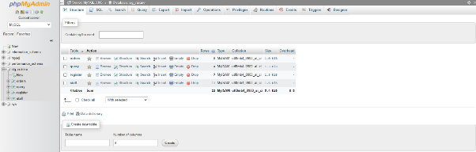

Considering above image, the Database is named as ‘sig_cuisine’. All the inserting data of “Signature Cusine” are store in this database.

There are 4 tables that create for the database. Named by ‘orders’, ‘query’, ‘register’ and ‘staff’. One each table has several types of columns.

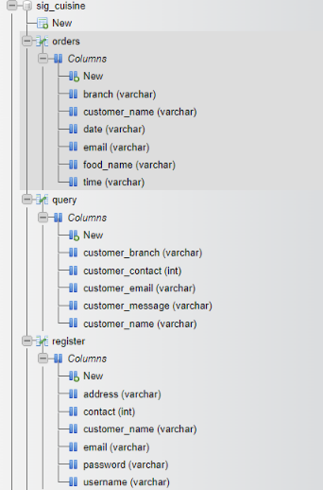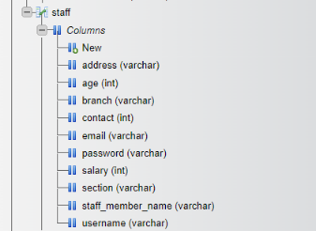

And there are few example for store real data’s,

1. Order table used to store ‘Customer Orders’.

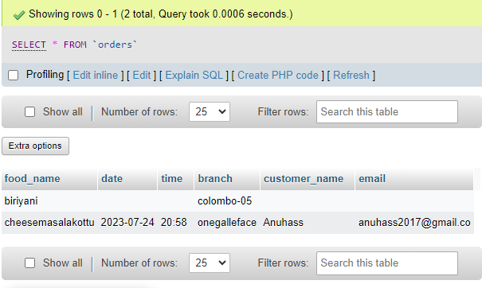

1. Query table is used to store feedback message data that customer entered. And this table can access by Staff Member and Administrator.

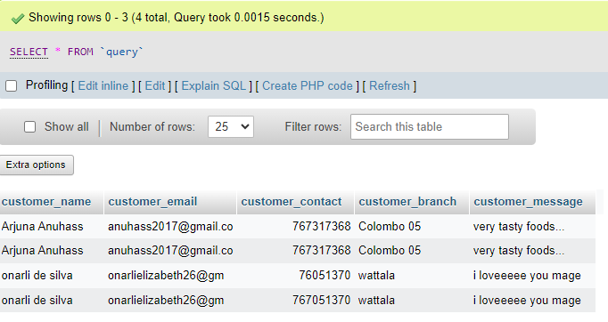

1. Register table is used to store data that a new customer registration.

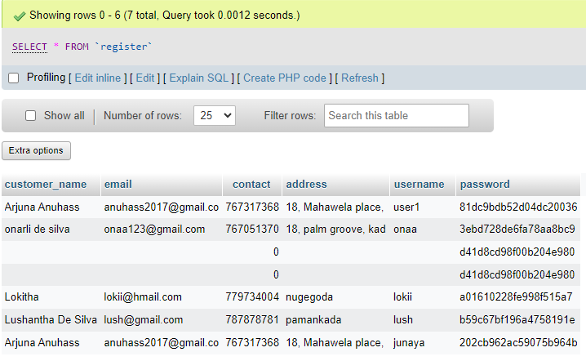

1. Staff table is used to store staff member details. And this can access to admin to delete or add staff members.

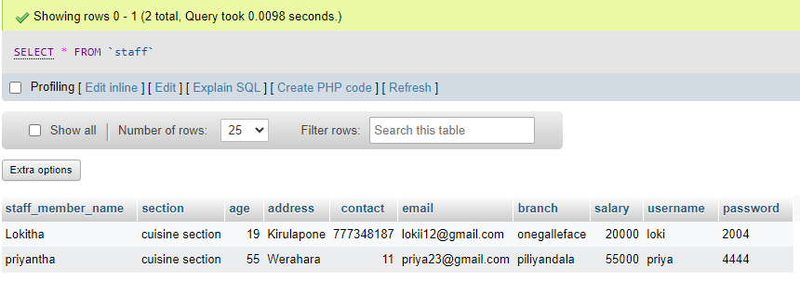

# TASK 03

## Testing

Testing in web development is a critical process that ensure the functionality, performance, and usability of a website before it is launched to the public. There are various types of testing involved in web development. And today we going to choose 3 methos for this web development. Those are,

1. Functional and User Testing.
2. Database Testing. (Back-end)
3. Security Testing.

Testing for Functional and User Testing.

|  |  |  |  |
| --- | --- | --- | --- |
| **Test case ID** | **Test Case Name** | **Scenario** | **Results** |
| Test01 | Check Admin Login | Enter correct username & password | Deflect to Admin home page |
| Test02 | Check Staff Login | Enter correct username & password | Deflect to Staff home page |
| Test03 | Check Customer Login | Enter correct username &password | Deflect to Customer home page |
| Test04 | Check Login | Enter Incorrect username & password | Display Alert (“Login Unsuccessfull!!!”) Direct to “ Please check your Username or Password!!!” |
| Test05 | Check Register | Add details and click ‘Add Details’ | Display Alert(“Data register successfully!”) Data regisiter Succesfully |
| Test06 | Check place order functionality in customer orders | Go to the customer order and place order with fill in the form | display Alert(“Order Placed Successfully..”) |
| Test07 | Check search function in staff section | Go to the staff section and view customer details and search by entering customer contact number | Display the order details of staff section |
| Test08 | Check search function in admin section | Go to the admin home and select view customer details and search by customer username | Display the customer details of admin section |
| Test09 | Check add staff member function in admin page | Go to the add new staff member, fill the form and hit add details button | Alert (“Staff Details added Successfull”) Staff Details added Successfull...direct to add doctor page |
| Test10 | Check delete function in admin page | Go to the admin page and select delete staff member and select staff member by their username | Alert(“Data Deleted Successful…”)  Direct to staff member delete page |
| Test11 | Check staff details in admin page | Go to the admin page and select view staff members and search by their contact number and hit search or click here to view all staff member details | Display a table of staff member details |
| Test12 | Check submit feedback message in contact us section | In Web.php contact us section fill the blanks and hit Tell Us | Display “Query data added Successfully” |
| Test13 | Check empty form validation of Customer login | Go to the Web.php and click Login button without entering any data | Display “Please fill out this field.” |
| Test14 | Check empty form validation of Staff login | Go to the Web.php and click Login button without entering any data | Display “Please fill out this field.” |
| Test15 | Check empty form validation of Admin login | Go to the Web.php and click Login button without entering any data | Display “Please fill out this field.” |
| Test16 | Checking Previous function | Go and check all previous buttons | Goes to back page properly. |

Testing for Database connection test

|  |  |  |  |
| --- | --- | --- | --- |
| Test17 | Check database connection | Select the database for admin function | Message :“ Database Connected successfully  Database connected: ” |

Testing for Security Test

|  |  |  |  |
| --- | --- | --- | --- |
| Test18 | Check encrypted of data on password field | Go to Register section and fill the fields and click add details button | In database password column should have encrypted data type |

**Test01**

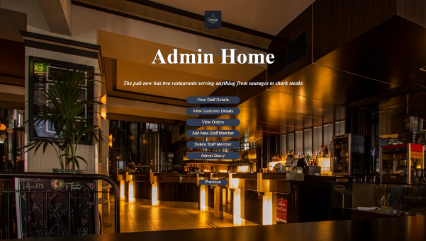

conclusion: Working Properly.

**Task02**

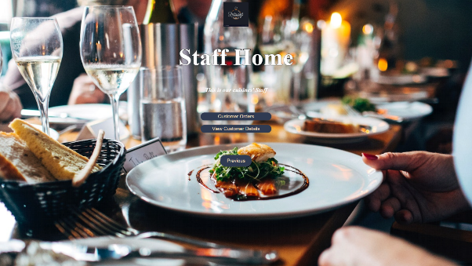

Conclusion: Working Properly.

**Task03**

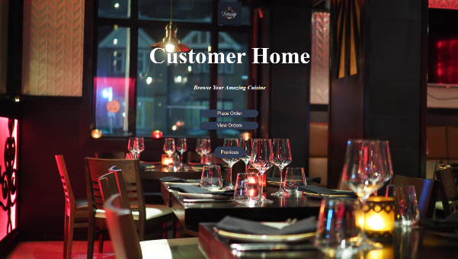

Conclusion: Working Properly.

**Task04**



Conclusion: Working Properly.

**Task05**



Conclusion: Working Properly.

**Task06**



Conclusion: Working Properly.

**Test07**

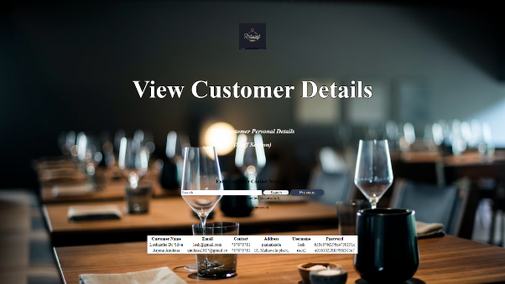

Conclusion: Working Properly.

**Test08**

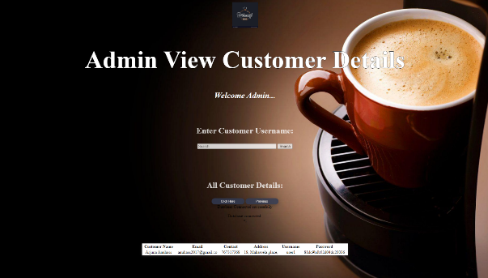

Conclusion: Working Properly.

**Task09**

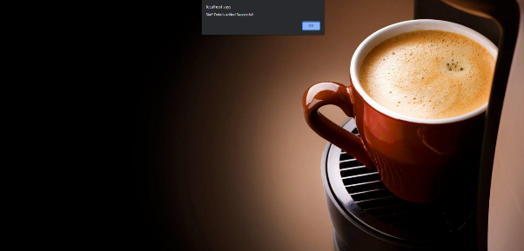

Conclusion: Working Properly.

**Task10**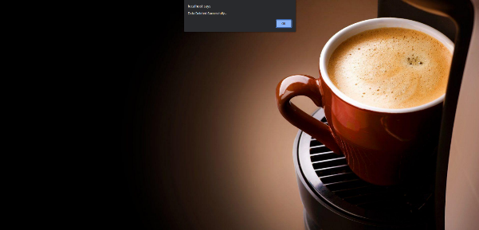

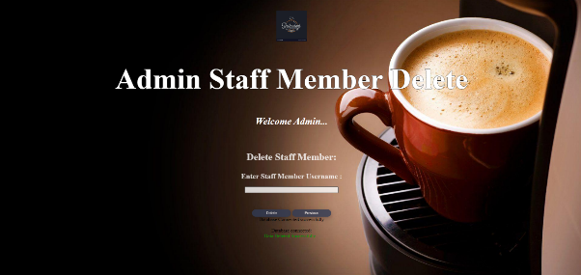

Conclusion: Working Properly.

**Task11**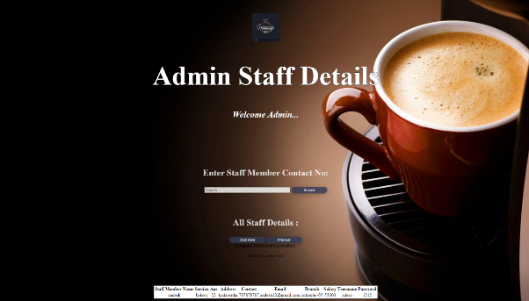

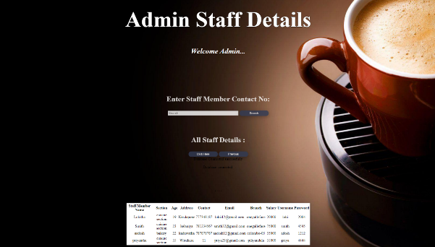

Conclusion: Working Properly.

**Task12**

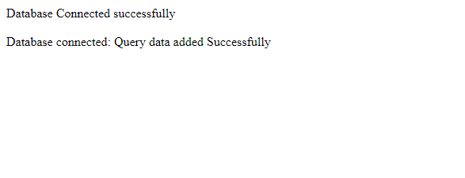

Conclusion: Working Properly.

**Task13**

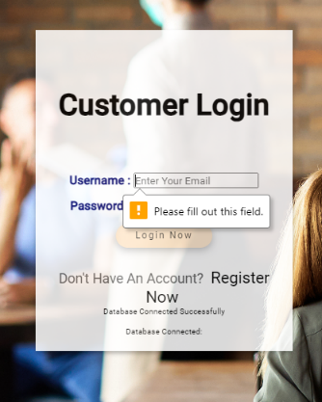

Conclusion: Working Properly.

**Task14**

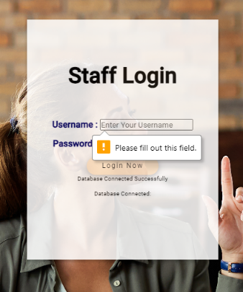

Conclusion: Working Properly.

**Task15**

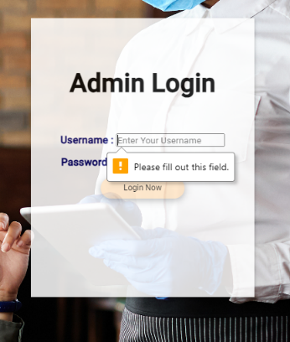

Conclusion: Working Properly.

**Task16**

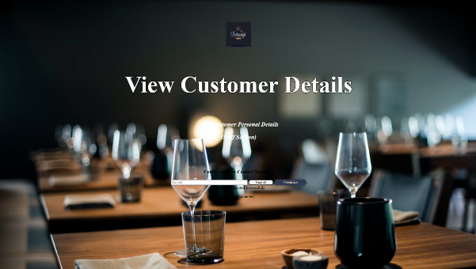

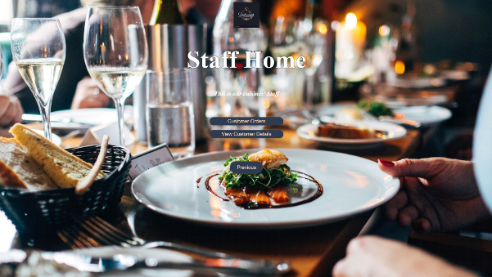

Conclusion: Working Properly.

**Task17**

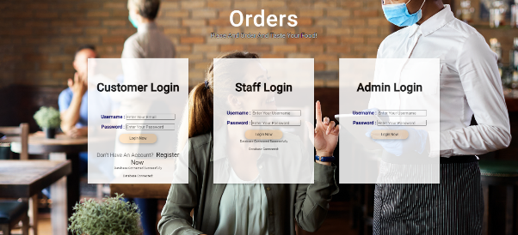

Conclusion: Working Properly.

**Task18**

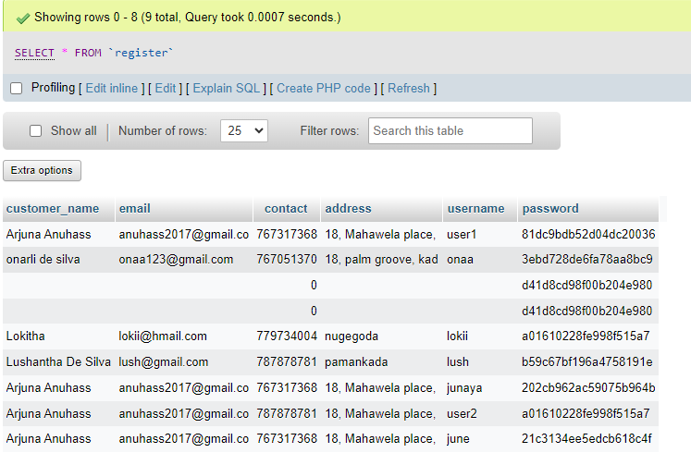

Conclusion: Working Properly.

(github, 2023)

# References

cafe, p. (2023). *peppermint cafe*. Retrieved from peppermintcafe.com: https://peppermintcafe.lk/our-menu/

github. (2023). *github*. Retrieved from github.com: https://github.com/

java. (n.d.). *javalounge*. Retrieved from javalounge.com: https://www.javalounge.lk/

runner, c. (2023). *creperunner*. Retrieved from creperunner.com: https://creperunner.lk/

veranda, c. (2023). *cocoveranda*. Retrieved from cocoveranda: https://www.cocoveranda.co/

